MBB Salary Breakdown 2026
Meta description: MBB salary in 2026: what McKinsey, BCG and Bain pay out of undergrad and post-MBA, the full ladder, how other strategy firms compare and a New York take-home example.

MBB salary is what McKinsey, BCG and Bain pay their consultants, and for an undergraduate hire in the United States the 2026 base is $110,000 to $112,000 depending on the firm and the tracker you read [VERIFY: Management Consulted 2026 salary report; Hacking the Case Interview, May and June 2026]. A first-year McKinsey, BCG or Bain consultant earns about $130,000 to $140,000 in total cash in year one, made up of base, a performance bonus and a $5,000 signing bonus, with a retirement contribution from the firm on top of that. [VERIFY: Management Consulted 2026; Hacking the Case Interview, June 2026] The firms don't publish their pay, so every number in this article comes from offer-letter trackers, and the trackers disagree with each other by a few thousand dollars. In this article, I lay out how the pay is built, what each firm pays at each level, how it compares with other strategy firms, and what a first year in New York takes home after tax.

How much do MBB consultants make out of undergrad?
A first-year undergraduate hire at McKinsey, BCG or Bain earns a base salary of $110,000 to $112,000 in 2026, a performance bonus that tops out between $18,000 and $22,500 depending on the firm, and a $5,000 signing bonus [VERIFY: Management Consulted 2026 report; Hacking the Case Interview firm pages, May to June 2026]. Add those up and the cash in a strong first year lands between $130,000 and $140,000. Counting the firm's retirement contribution and a relocation payment, the full first-year package at each firm runs roughly $140,000 to $155,000. [VERIFY: retirement and relocation figures per firm, Management Consulted 2026] The role titles differ by firm: McKinsey calls the undergrad hire a Business Analyst, BCG calls it an Associate, and Bain calls it an Associate Consultant. For how to land one of these offers, WSG's guide to breaking into MBB covers the timeline and the interviews.

Which of McKinsey, BCG and Bain pays the most?
Within a few thousand dollars, the three firms pay the same, and the differences sit in the bonus cap and the retirement contribution rather than the base. McKinsey and Bain both pay a $112,000 base in 2026, BCG pays $110,000, and all three pay a $5,000 signing bonus. [VERIFY: Management Consulted 2026 report] Bain's performance bonus caps highest at $22,500, BCG's at $22,000 and McKinsey's at $18,000, while McKinsey's retirement contribution of 7.5 percent of pay is the most generous of the three [VERIFY: Management Consulted 2026]. If you're choosing between two of these offers on money alone, you're choosing between packages that differ by a few thousand dollars a year, and most of that difference sits in the retirement account rather than the paycheck.

How MBB pay is structured
Every MBB offer letter breaks pay into the same pieces, and the pieces behave differently. The base arrives in regular paychecks. The rest arrives once, or once a year, or lands in an account you can't touch until retirement.

Here's each piece in plain words.

Base salary is the one number that's the same for every new hire at a firm, and it doesn't move for your office or your negotiation. Management Consulted's 2026 report notes that MBB salaries are flat across all offices within a country, so a Business Analyst in Atlanta and one in New York earn the same $112,000 [VERIFY: Management Consulted 2026 report]. The firms don't negotiate base with new graduates. What you can sometimes move is the start date, and occasionally the relocation amount.

The performance bonus is a once-a-year payment that depends on your annual review. Your offer letter states it as a ceiling: "up to $18,000" at McKinsey, "up to $22,000" at BCG, "up to $22,500" at Bain [VERIFY: Management Consulted 2026 report]. At the end of each year the firm rates your work, and the rating places you in a tier. The top tier gets the full amount, the middle tiers get a portion, and a weak year can mean little or nothing. Bain is the one firm where the trackers show a target as well as a cap: a $15,000 target against the $22,500 maximum [VERIFY: Management Consulted 2026]. Hacking the Case Interview's estimate for Bain is that top performers earn close to the maximum and average performers get about 50 to 70 percent of it, which on McKinsey's $18,000 cap would be $9,000 to $12,600 [VERIFY: Hacking the Case Interview Bain salary page, June 2026]. So when a tracker says "total cash up to $135,000," read it as the best case, and plan on $5,000 to $11,000 less depending on the firm's cap.

The signing bonus is a one-time $5,000 payment at all three firms for undergraduate hires, paid around your start date [VERIFY: Management Consulted 2026]. It's taxed as ordinary wages. It usually comes with a clawback: if you leave within the first year, you owe it back [VERIFY: clawback terms per firm offer letter; Hacking the Case Interview, June 2026]. The clawback matters if you're thinking about jumping to a private equity seat eight months in.

Relocation and housing money covers the move. McKinsey pays up to $10,000 in relocation, BCG up to $6,000 if you move more than 500 miles, and Bain up to $5,000, or up to $10,000 for a New York start [VERIFY: Management Consulted 2026 report]. McKinsey and Bain also list a housing allowance of up to $5,000 in some offices [VERIFY: Management Consulted 2026, listed as geography dependent]. Management Consulted notes that if you already live in the office's city, the relocation payment can shrink to about $2,000 or disappear [VERIFY: Management Consulted 2026].

The retirement contribution is money the firm puts into your 401(k) whether or not you put in anything yourself, and it's the biggest hidden difference between the three offers. A 401(k) is a retirement account where money goes in before income tax is taken out and grows untaxed until you withdraw it after age 59 and a half. Most employers only add money if you add money first, which is called a match. McKinsey and Bain skip the match and simply deposit a percentage of your pay. McKinsey contributes 7.5 percent of base plus bonus, which on $124,000 of pay is $9,300 a year [VERIFY: Management Consulted 2026; Hacking the Case Interview, June 2026]. Bain contributes 4.5 percent of base plus bonus, up to about $6,050 [VERIFY: Management Consulted 2026]. BCG makes a profit-sharing deposit into your 401(k) of up to about $4,400 in year one [VERIFY: Management Consulted 2026; Hacking the Case Interview puts it at 5 percent of base and bonus]. That money never shows up in your paycheck, so it's easy to ignore when you compare offers, and over a two-year analyst stint the McKinsey contribution is worth roughly $10,000 more than BCG's.

The rest of the package is benefits: health insurance, paid time off, and in some offices a phone and meal allowances. Paid time off differs more than you'd expect: Bain lists 20 days, McKinsey 19 and BCG 15 [VERIFY: Management Consulted 2026 report]. None of it changes your pay, but 20 days against 15 is a full extra week a year.

Undergrad pay at McKinsey, BCG and Bain side by side
The table below uses Management Consulted's 2026 report as the main source because it's built from written offer letters, and it shows where Hacking the Case Interview and StrategyCase differ [VERIFY: every row; Management Consulted 2026 report; Hacking the Case Interview, May and June 2026; StrategyCase, August 2026].

Component | McKinsey Business Analyst | BCG Associate | Bain Associate Consultant
Base salary | $112,000 | $110,000 (HTCI: $115,000) | $112,000
Performance bonus | Up to $18,000 | Up to $22,000 (HTCI: $15,000 to $20,000) | Up to $22,500 (target $15,000)
Signing bonus | $5,000 | $5,000 | $5,000
Relocation | Up to $10,000 | Up to $6,000 (500+ miles) | Up to $5,000 ($10,000 for NYC)
Housing allowance | Up to $5,000 (some offices) | Not listed | Up to $5,000
Retirement contribution | 7.5% of base plus bonus | Profit sharing up to $4,400 into 401(k) | 4.5% of base plus bonus, up to $6,050
Paid time off | 19 days | 15 days | 20 days
Total cash, best case | $135,000 | $137,000 | $139,500

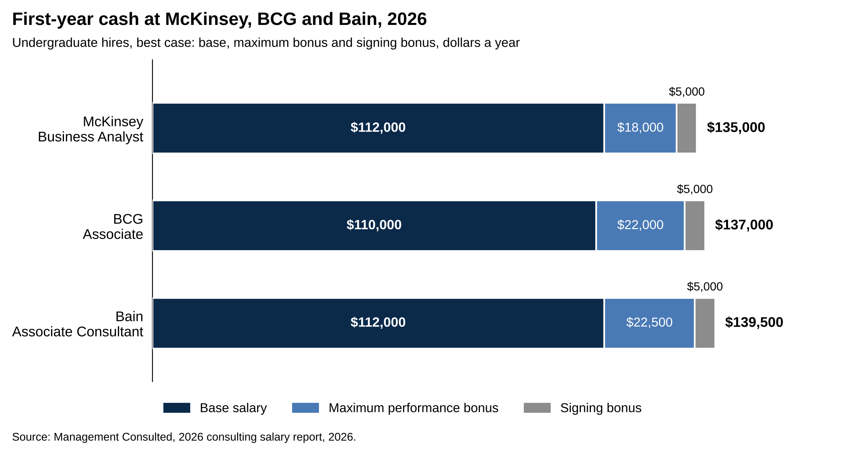
Best-case first-year cash is $135,000 at McKinsey, $137,000 at BCG and $139,500 at Bain.
Source: Management Consulted, 2026 consulting salary report, 2026.

The "total cash, best case" row adds base, the full bonus and the signing bonus. A typical first year, with the bonus at 50 to 70 percent of the cap, is $5,000 to $11,000 lower at each firm.

The offer-letter trackers agree on the base to within $5,000 and disagree on the bonus by up to $12,000, so the bonus line is where to be careful. Management Consulted and Hacking the Case Interview both put McKinsey's bonus cap at $18,000 [VERIFY: both sources, 2026]. StrategyCase, which updated its pages on August 31, 2026, puts the target bonus at $20,000 on a $120,000 base at all three firms and estimates year-one all-in pay at $155,000 to $165,000 once a $10,000 to $15,000 signing bonus and relocation are included [VERIFY: StrategyCase MBB salaries page, August 2026]. Those signing figures are two to three times what the other two trackers report. The live McKinsey salary post on WSG, updated in September 2026, uses the same $110,000 to $112,000 base as this article but estimates the Business Analyst bonus at about $30,000, which puts its year-one total at $140,000 to $160,000, between the offer-letter trackers and StrategyCase [VERIFY: WSG McKinsey salary post, updated September 28, 2026]. When trackers split like this, the offer letter in your hand is the only number that counts.

One more thing to know if you're holding or expecting a 2027 offer. StrategyCase reported in August 2026 that McKinsey told incoming US Business Analysts their base will rise from $112,000 to $120,000 effective January 2027, that Bain matched at $120,000, and that BCG told offer holders revised letters were coming [VERIFY: StrategyCase, August 31, 2026; the page names no primary source]. Management Consulted's 2026 report, published earlier in the year, says 2026 starting salaries stayed flat and expects muted growth in 2027 [VERIFY: Management Consulted 2026 report]. No firm had announced the change publicly by October 2026, and no second tracker had confirmed it, so this article keeps the $110,000 to $112,000 base. StrategyCase's own read is that the raise shifts money from bonus into base rather than adding to the total, so even if it's real, year-one cash lands in the same $135,000 to $145,000 zone [VERIFY: StrategyCase, August 2026]. If your offer letter says $120,000, that's the number. If it says $112,000, ask your recruiter whether a revised letter is coming before you sign.

For a deeper look at the McKinsey side, including how the Business Analyst role and its pay compare with the Associate level, read WSG's McKinsey salary breakdown and the McKinsey Business Analyst guide.

The MBB pay ladder from analyst to partner
The three ladders have different names and the same shape: an analyst level for two to three years, a post-MBA level for two to three years, a manager level that runs a case team, a junior partner level, then partner. Pay roughly doubles at the first jump and reaches $350,000 to $600,000 at the junior partner level.

At McKinsey the ladder runs Business Analyst, Associate, Engagement Manager, Associate Partner, Partner; at BCG it's Associate, Consultant, Project Leader, Principal, Partner; at Bain it's Associate Consultant, Senior Associate Consultant, Consultant, Manager, Associate Partner, Partner. [VERIFY: Hacking the Case Interview firm pages, April to June 2026] Bain's Senior Associate Consultant is a step inside the analyst years, usually reached about a year in, rather than a separate pay level [VERIFY: Hacking the Case Interview Bain career levels page, April 2026].

The table gives total cash, meaning base plus bonus, at each level, with the years counted from an undergraduate start. The ranges span three trackers. The low ends are mostly StrategyCase's target-bonus figures and Management Consulted's offer-letter figures, and the high ends are Hacking the Case Interview's maximum-bonus figures, which is why the ranges are wide [VERIFY: every row; StrategyCase, August 2026; Hacking the Case Interview, April to June 2026; Management Consulted 2026].

Level (years in) | McKinsey | BCG | Bain
Analyst level (0 to 3) | $130,000 to $135,000 | $130,000 to $140,000 | $134,500 to $140,000
Post-MBA level (3 to 6) | $242,000 to $267,000 | $210,000 to $240,000 | $230,000 to $285,000
Manager level (6 to 8) | $280,000 to $350,000 | $275,000 to $425,000 | $290,000 to $350,000
Junior partner level (8 to 11) | $400,000 to $600,000 | $356,000 to $456,000 | $360,000 to $500,000
Partner (11+) | $700,000 to $1.5 million+ | $700,000 to $2 million+ | $650,000 to $1.5 million+

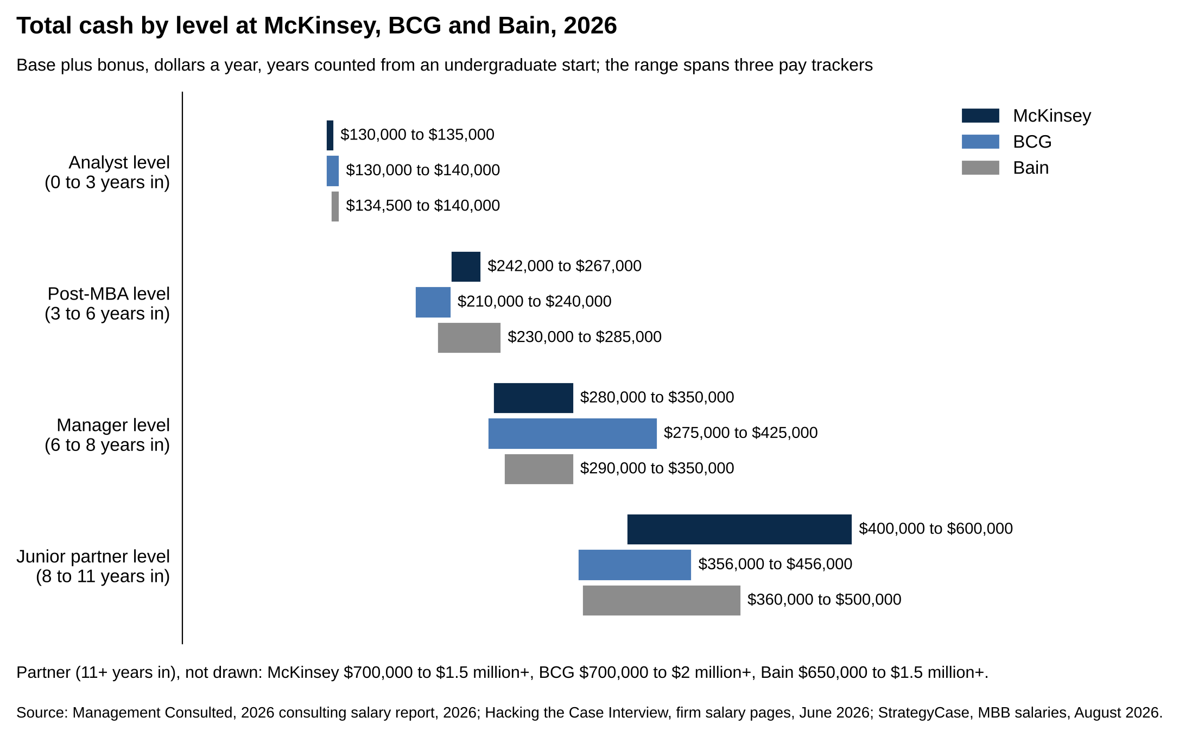
Total cash goes from $130,000 to $140,000 at the analyst level to $210,000 to $285,000 at the post-MBA level.
Source: Management Consulted, 2026 consulting salary report, 2026; Hacking the Case Interview, firm salary pages, June 2026; StrategyCase, MBB salaries, August 2026.

Base salary at each level is closer across the firms than the table suggests. The post-MBA base is $192,000 at McKinsey and Bain and $190,000 at BCG [VERIFY: Management Consulted 2026 report]. The manager-level base is about $220,000 to $250,000 at all three [VERIFY: Hacking the Case Interview, 2026]. What widens the ranges is the bonus, which grows from about 15 percent of base at the analyst level to 25 to 30 percent at the manager level and 35 to 55 percent at the junior partner level [VERIFY: StrategyCase, August 2026].

The two jumps that matter most are the promotion to the post-MBA level, where base goes from about $112,000 to about $192,000, and the move to partner, where salary turns into a share of the firm's profits. At the partner level, bonus stops being a percentage of base and becomes profit sharing, meaning a slice of what the firm earned that year, which is why partner pay is quoted as a range from $650,000 to several million [VERIFY: StrategyCase, August 2026; Hacking the Case Interview, 2026]. Management Consulted's growth model for a top firm puts a senior partner at a $500,000 to $700,000 base plus $500,000 or more in bonus, and notes that many firms run an up-or-out system: each level comes with a time limit, and a consultant who isn't promoted by the end of it is asked to leave [VERIFY: Management Consulted 2026 report].

Between promotions, pay still climbs. Management Consulted says to expect a 10 to 20 percent increase in base and bonus each year at a top firm [VERIFY: Management Consulted 2026 report]. On a $112,000 base, a 10 percent raise is $11,200, so a second-year analyst is earning about $123,000 before bonus, and a second raise of the same size puts a third-year near $136,000 [VERIFY: arithmetic from Management Consulted's 10 to 20 percent figure, not a reported number]. Hacking the Case Interview's $130,000 to $145,000 base for a McKinsey Senior Business Analyst lands in the same place [VERIFY: Hacking the Case Interview McKinsey salary page, 2026].

Post-MBA pay and how MBA sponsorship works
A post-MBA hire at McKinsey or Bain starts at a $192,000 base, and at BCG at $190,000, with a $30,000 signing bonus at all three. [VERIFY: Management Consulted 2026 report] The performance bonus caps at $40,000 at McKinsey, $47,500 at BCG and $63,000 at Bain, so maximum first-year cash runs from $262,000 at McKinsey to $285,000 at Bain [VERIFY: Management Consulted 2026; Hacking the Case Interview, June 2026]. Relocation is bigger too: Bain pays $8,000 for a move under 400 miles and $15,000 over it, McKinsey up to $10,100, BCG up to $6,000 [VERIFY: Management Consulted 2026]. The retirement contribution scales with pay: McKinsey's 7.5 percent on $232,000 is $17,400, Bain's 4.5 percent caps at $11,475, and BCG deposits $11,875 into the 401(k) [VERIFY: Management Consulted 2026 report].

The question for an undergraduate hire is how you get to that level, because there are two doors. The first is direct promotion. All three firms promote strong analysts to the post-MBA level without a degree, usually after two to three years, and at Bain the top-performing Senior Associate Consultants move straight into the Consultant level, some of them in under two years [VERIFY: Hacking the Case Interview, Bain career levels, April 2026]. The second door is sponsorship.

MBA sponsorship means the firm pays for your business school in exchange for your coming back. Management Consulted describes it as full tuition plus a living stipend of roughly $10,000 to $20,000, with a requirement to return for at least two years after graduation [VERIFY: Management Consulted MBA sponsorship page, undated; StrategyCase puts the stipend higher, at $30,000 to $50,000 a year]. StrategyCase estimates the full value at $250,000 to $350,000 once tuition, stipend and summer pay are counted, and says the firms claw back a prorated share, with interest, if you leave before the two years are up [VERIFY: StrategyCase, May 2026; the page notes the firms don't publish sponsorship terms]. Prorated means scaled to the time you didn't serve: leave after one year of a two-year commitment and you owe about half. Eligibility usually comes after two to three years at the analyst level and a good record, and in practice an acceptance from a top ten program [VERIFY: Management Consulted and StrategyCase, 2026]. Sponsored analysts return at the post-MBA level and the post-MBA pay above, so the degree costs them two years of salary rather than two years of salary plus the $160,000 to $185,000 of tuition that StrategyCase estimates for two years at a top program [VERIFY: StrategyCase, May 2026].

The math on sponsorship is simple. A sponsored analyst gives up about $140,000 a year of consulting pay for two years, gets some of it back as the stipend, and returns to a $192,000 base. An unsponsored MBA pays the same two years of lost salary plus tuition. Direct promotion skips both. Which door you take depends on whether you want the degree itself, because the base on the other side is the same $192,000.

MBB vs investment banking pay in year one and year three
A first-year investment banking analyst at a bulge bracket or elite boutique earns $165,000 to $225,000 all-in in 2026, against $130,000 to $140,000 at MBB, so banking pays $35,000 to $85,000 more before tax in year one. [VERIFY: Mergers & Inquisitions 2026 salary report, based on mid-2025 analyst payouts; Management Consulted 2026 for MBB] By year three the gap is $50,000 to $95,000, with a third-year banking analyst at $200,000 to $270,000 in the Mergers & Inquisitions 2026 report and an MBB analyst who hasn't yet been promoted near $150,000 to $175,000 [VERIFY: Mergers & Inquisitions 2026; MBB figure is an estimate from Management Consulted's 10 to 20 percent annual growth figure]. MBB analysts average 55 to 65 hours a week and banking analysts 70 to 90 [VERIFY: StrategyCase consulting vs investment banking page, September 2026]. At $135,000 for a 60-hour week over 48 weeks, an MBB analyst earns about $47 an hour; at $190,000 for an 80-hour week, a banking analyst earns about $49, so per hour the two pay about the same [VERIFY: arithmetic on the ranges above].

Year | MBB (total cash) | Investment banking (total cash) | Gap
Year one | $130,000 to $140,000 | $165,000 to $225,000 | $35,000 to $85,000
Year three | $150,000 to $175,000 | $200,000 to $270,000 | $50,000 to $95,000

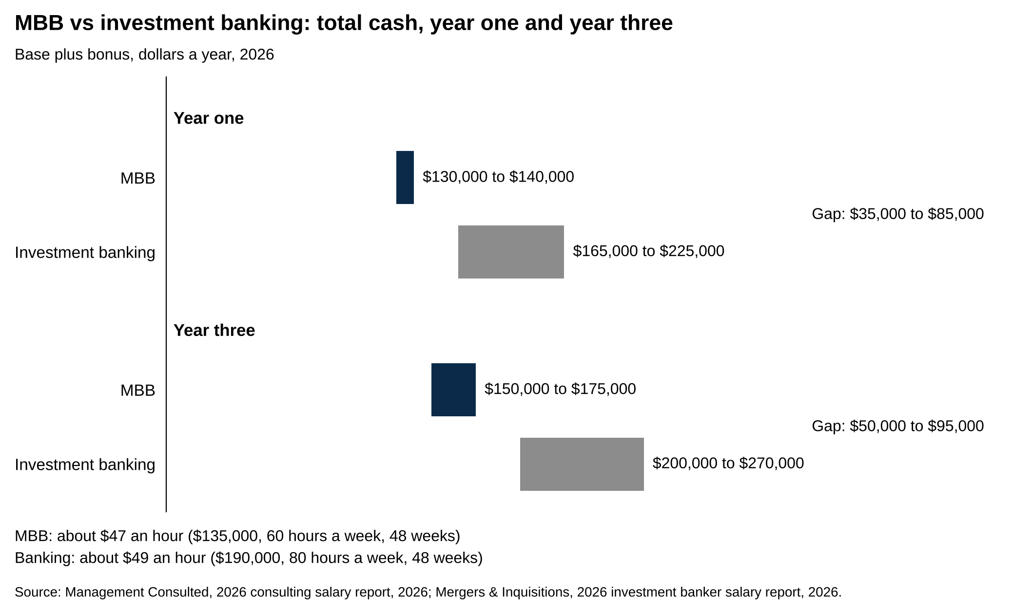
Banking pays $35,000 to $85,000 more than MBB in year one and $50,000 to $95,000 more in year three.
Source: Management Consulted, 2026 consulting salary report, 2026; Mergers & Inquisitions, 2026 investment banker salary report, 2026.

[VERIFY: MBB rows per Management Consulted 2026 and the growth estimate above; banking rows per Mergers & Inquisitions 2026 report]

MBB vs tier 2 and Big 4 strategy pay
Tier 2 and Big 4 strategy firms pay a $95,000 to $110,000 undergraduate base in 2026, which puts them up to $17,000 behind MBB on base, with bonus caps that overlap MBB's $18,000 to $22,500. [VERIFY: Management Consulted 2026 report]

Firm | Base | Performance bonus cap | Signing bonus
McKinsey, BCG, Bain | $110,000 to $112,000 | $18,000 to $22,500 | $5,000
Oliver Wyman | $110,000 | $18,700 | $10,000
Accenture Strategy | $105,000 | $30,000 | $12,500
Kearney | $100,000 | $15,000 (plus profit sharing up to $8,500) | $10,000
Strategy& | $100,000 | $27,000 | $5,000
EY-Parthenon | $100,000 | $22,000 | $8,000
L.E.K. | $95,000 | $3,000 (plus profit sharing up to $19,000) | $10,000
Deloitte Consulting Services | $100,000 | None until year three | $12,500

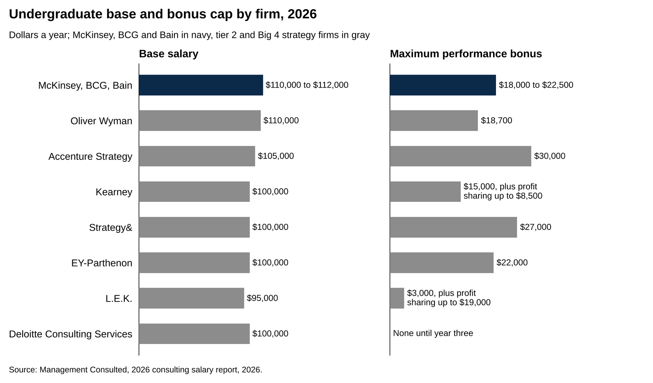
Tier 2 and Big 4 strategy bases run $95,000 to $110,000 against $110,000 to $112,000 at MBB.
Source: Management Consulted, 2026 consulting salary report, 2026.

[VERIFY: every row, Management Consulted 2026 salary report, undergraduate and master's section]

Signing bonuses are the one line where most tier 2 firms pay more than MBB, at $8,000 to $12,500 against $5,000. At the post-MBA level the base gap mostly closes: Oliver Wyman and Strategy& pay a $190,000 post-MBA base, the same as BCG, Kearney pays $188,000 and L.E.K. $185,000, while Accenture Strategy, EY-Parthenon and Deloitte Consulting Services sit at $175,000, about $15,000 to $17,000 behind MBB [VERIFY: Management Consulted 2026 MBA section].

What a first-year MBB consultant takes home in New York
Take one Business Analyst at McKinsey's New York office. Single, no kids, lives in Manhattan, earns the $112,000 base and a $12,000 performance bonus in the same calendar year, which is about two-thirds of the $18,000 cap. That's $124,000 of gross pay. The $5,000 signing bonus is left out because it's a one-time payment, taxed as wages in the year it arrives. The example uses the 2026 tax rules, which are the latest the IRS and New York have published [VERIFY: IRS Revenue Procedure 2025-32 for 2026; New York Form IT-2105-I (2026); replace with 2027 parameters once published].

Five taxes come out of that $124,000. Here they are in the order payroll takes them.

Federal income tax is the largest line, and it works in slices, so being "in the 24 percent bracket" doesn't mean paying 24 percent on everything. Start with $124,000. Subtract the 2026 standard deduction for a single filer, $16,100, which is income the federal government doesn't tax at all [VERIFY: $16,100 single standard deduction, IRS Rev. Proc. 2025-32]. That leaves $107,900 of taxable income. Each slice of it is taxed at its own rate.

Taxable income slice | Rate | Dollars in slice | Tax
$0 to $12,400 | 10% | $12,400 | $1,240
$12,400 to $50,400 | 12% | $38,000 | $4,560
$50,400 to $105,700 | 22% | $55,300 | $12,166
$105,700 to $107,900 | 24% | $2,200 | $528
Total federal income tax |  | $107,900 | $18,494

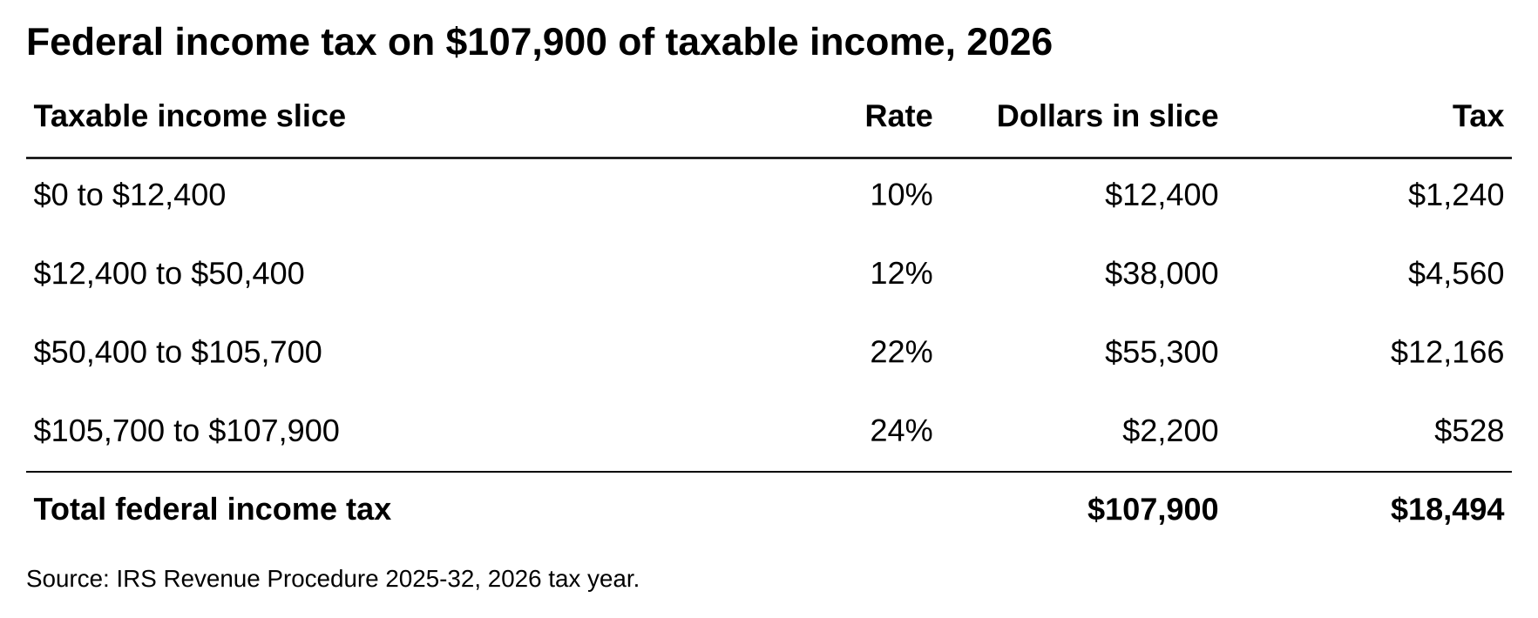
The four slices add to $18,494 of federal income tax on $124,000 of gross pay.
Source: IRS Revenue Procedure 2025-32, 2026 tax year.

[VERIFY: 2026 single-filer brackets of 10, 12, 22 and 24 percent with thresholds at $12,400, $50,400, $105,700 and $201,775, IRS Rev. Proc. 2025-32]

The first $12,400 is taxed at 10 percent, the next $38,000 at 12, the next $55,300 at 22, and only the last $2,200 at 24. Add the four slices and the federal bill is $18,494. That's 14.9 percent of gross pay. The 24 percent is the marginal rate, meaning the tax on the next dollar you earn. The 14.9 percent is the effective rate, meaning the average across all your dollars. The marginal rate tells you what a bigger bonus is worth. The effective rate tells you what your year cost.

Social Security comes next at 6.2 percent of wages, up to a cap of $184,500 in 2026 [VERIFY: 2026 wage base per the Social Security Administration]. Our analyst is under the cap, so the tax is 6.2 percent of $124,000, or $7,688. Medicare is 1.45 percent of all wages with no cap, so $1,798 [VERIFY: 1.45 percent Medicare rate, IRS Publication 15 (2026)]. Together the two payroll taxes take $9,486.

New York State has its own standard deduction of $8,000 for a single filer, so New York taxable income is $116,000 [VERIFY: $8,000 standard deduction, Form IT-2105-I (2026)]. The state's 2026 rate schedule starts at 3.9 percent and climbs to 5.9 percent on income between $80,650 and $215,400 [VERIFY: 2026 single-filer schedule, Form IT-2105-I (2026), page 10]. Run $116,000 through that schedule and the tax is $6,277. New York then adds one more step. Once your income passes $107,650, the state starts phasing out the lower brackets, so that by $157,650 your whole taxable income is taxed at a flat 5.9 percent [VERIFY: the tax computation worksheet for single filers with New York adjusted gross income over $107,650, Form IT-2105-I (2026)]. A flat 5.9 percent on $116,000 would be $6,844, which is $567 more than the schedule. Our analyst's $124,000 of income is $16,350 past the $107,650 line, out of a $50,000 phase-in band, so 32.7 percent of that $567 gets added back. That's $185. New York State tax is $6,462.

New York City taxes residents of the five boroughs on the same $116,000, in four slices.

NYC taxable income slice | Rate | Dollars in slice | Tax
$0 to $12,000 | 3.078% | $12,000 | $369
$12,000 to $25,000 | 3.762% | $13,000 | $489
$25,000 to $50,000 | 3.819% | $25,000 | $955
$50,000 to $116,000 | 3.876% | $66,000 | $2,558
Total NYC tax |  | $116,000 | $4,371

[VERIFY: 2026 New York City resident single-filer schedule, Form IT-2105-I (2026)]

Put it all together.

Line | Amount
Base salary | $112,000
Performance bonus | $12,000
Gross pay | $124,000
Federal income tax | $18,494
Social Security (6.2%) | $7,688
Medicare (1.45%) | $1,798
New York State tax | $6,462
New York City tax | $4,371
Total taxes | $38,813
Take-home pay | $85,187
Take-home as a share of gross | 68.7%
Take-home per month | $7,099

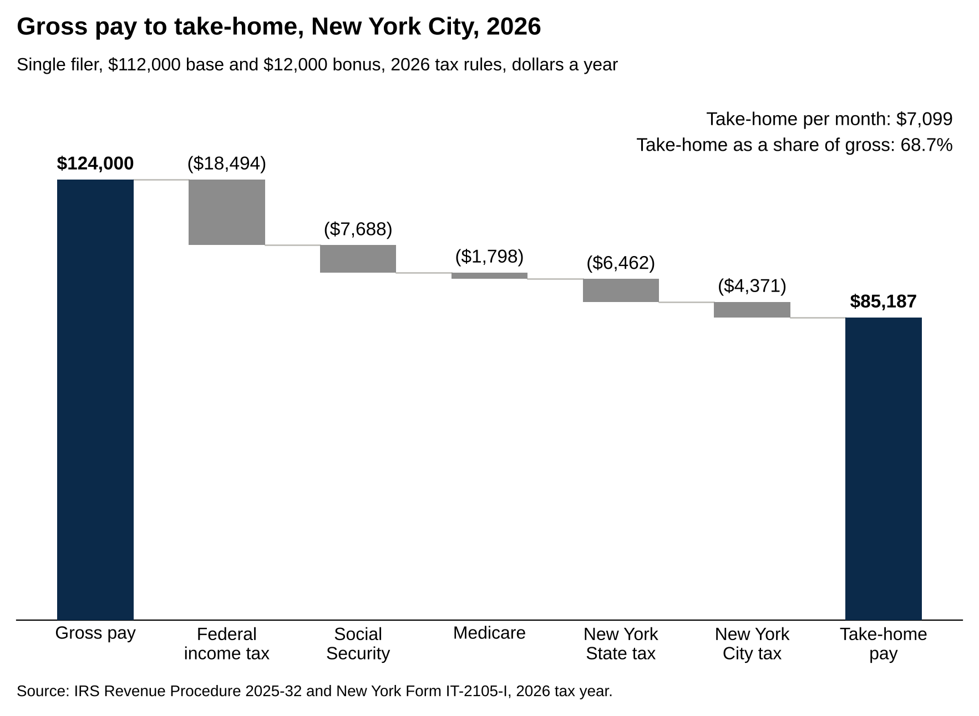
Taxes take $38,813 of the $124,000, leaving $85,187 a year, or $7,099 a month.
Source: IRS Revenue Procedure 2025-32 and New York Form IT-2105-I, 2026 tax year.

[VERIFY: every input above per the sources in this section; arithmetic recomputed in Python before delivery]

A $124,000 first-year McKinsey salary in New York City becomes $85,187 of take-home, about $7,099 a month, with 14.9 percent of gross going to federal income tax, 7.7 percent to Social Security and Medicare, 5.2 percent to the state and 3.5 percent to the city. The monthly figure is an average that includes the bonus. Your actual paychecks on base alone come to about $6,500 a month, and the $12,000 bonus arrives as a separate payment of roughly $7,100 after taxes [VERIFY: base-only take-home of $78,098 under the same assumptions]. At this income in New York, about 41 cents of each extra bonus dollar goes to taxes, which is the marginal rate in action.

Now the 401(k). McKinsey's 7.5 percent contribution on $124,000 is $9,300, and it goes into the account on top of the $85,187 without touching it [VERIFY: 7.5 percent of base plus bonus, Management Consulted 2026]. If you also put 6 percent of your own pay into the 401(k), that's $7,440. It comes out before federal, state and city income tax, so those three taxes fall by about $2,490, and your take-home drops by $4,948 rather than the full $7,440. Social Security and Medicare still apply to the whole $124,000. Each $1,000 you save costs about $665 of take-home. Do that and the year ends with $80,239 in your checking account and $16,740 in the retirement account [VERIFY: arithmetic under the 2026 parameters above].

One note on the calendar. A fall start means your first calendar year holds only three or four months of base and no full bonus, so your first W-2, the annual wage statement your employer files, is small and taxed lightly. The second calendar year, with twelve months of base and the first full bonus, is the one the table describes.

What the offer letter leaves out
The offer letter gives you the ceiling on the bonus and the date of the signing bonus, and it says nothing about when the bonus is paid, what you owe if you leave, or when the base first moves.

Here is what to ask about before you sign, in the order it'll matter.

The performance bonus is paid once a year after the annual review cycle, not at the end of your first twelve months. If you start in September, your first review may cover only part of a year, and the first bonus is usually scaled down to the months you worked [VERIFY: proration practice per firm; Hacking the Case Interview says the bonus is driven by the annual performance rating, June 2026]. Ask your recruiter what the first full bonus year looks like for someone with your start date.

Relocation money often comes with a repayment term like the signing bonus clawback, so an exit in the first year can cost you both [VERIFY: relocation repayment terms per firm offer letter]. Find the repayment line for each one in the offer letter.

The first base raise comes with the first annual review, not on your anniversary. A fall starter can wait more than a year for the first step up, because the review calendar runs on the firm's year, not yours [VERIFY: review and raise calendar per firm].

Retirement money vests on different schedules. Vesting is the point at which the firm's contribution becomes yours to keep if you leave. Bain's contribution vests immediately, meaning it's yours the day it's deposited [VERIFY: Hacking the Case Interview, June 2026, citing Glassdoor data]. Check the vesting schedule at McKinsey and BCG before you count the contribution as yours. A schedule that vests over three years means an analyst who leaves after two forfeits part of it [VERIFY: vesting terms per firm benefits summary].

The office changes how much of your pay you keep. Because MBB pay is flat across US offices, a Business Analyst in Dallas, where Texas has no state income tax, keeps the roughly $10,800 of state and city tax from the example above and pays lower rent on top [VERIFY: Management Consulted 2026 on flat pay across offices; Texas has no personal income tax; state and city arithmetic above]. Office choice is the one decision about take-home pay that the firms leave to you.

Before you sign, find four lines in the offer letter: the bonus ceiling, the signing bonus repayment term, the retirement contribution with its vesting schedule, and the relocation amount. If the base reads $112,000 and you start in 2027, also ask whether a revised letter is coming.

How to talk about MBB pay with recruiters and consultants
MBB bases are set firmwide for new graduates, so the pay questions worth asking are about the start date, relocation and how the first bonus works. Three ways to handle it.

Say this: "Is there any flexibility on the start date or the relocation amount?" Don't say that: "Can you match the base in my other offer?" Asking to move the base signals you don't know how the pay works.

Say this: on a networking call, "How did the bonus work out in your first year, given the fall start?" Don't say that: "What did you get as a bonus?" The first version asks about the mechanism and gets a useful answer. The second asks for a number people won't give.

Say this: when a recruiter asks what you know about compensation, give the structure in one sentence: "A base around $112,000, a performance bonus that tops out near $18,000 to $22,500, a $5,000 signing bonus and a retirement contribution." Don't say that: a Glassdoor average quoted as fact. The trackers built on offer letters are closer, and saying "the trackers show" tells the recruiter you did the reading.

